Final Report

Solar Array Weather Station

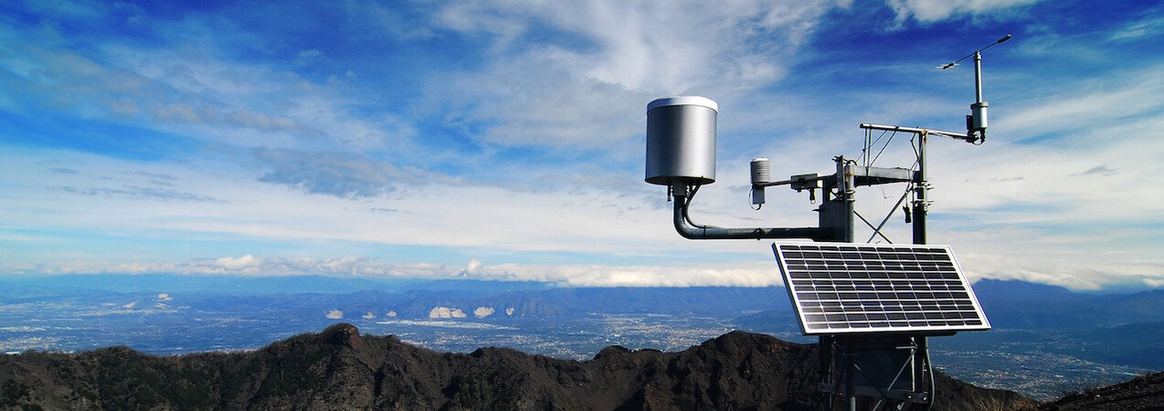

Prepared for Professor Haggerty’s EE400D

California State University, Long Beach

Team:

Garrett Bondoc

James Donahue

Jordan Hsu

Sakib Karim

Matthew Rosales

Table of Contents

Background and Concept Introduction: 3

Product Concept Statement: 4

Technical objectives: 5

Acceptance Testing : 6

Demonstration Results: 6

Lessons Learned: 7

Significant Changes: 7

Key Personnel: 8

Final Parts List/Cost: 9

References 10

# Background and Concept Introduction:

With the urgency of global preservation and demand for energy alternatives on the rise, solar energy has been a growing field of development. According to the Center for Climate and Energy Solutions, total global energy capacity has seen 40% annual growth from 2000 to 2011, from 1.5 GW to 69.8 GW. From 2009 to 2012, the average cost per installed watt of solar power systems in the United States has decreased from $7.50/watt to $4.44/watt. In 2011, solar power has accounted for 0.5% of global electricity demand in 2011 and has only seen rapid growth since then.3

The photovoltaic effect, the main principle behind solar panels, is a quantum mechanical effect which involves the study of atomic particles. Solar energy is observed as a bi-behavioral radiation, consisting of traveling waves and photons that are discrete packets of light energy. .The photoelectric effect describes a process in which metal atoms absorb energy from light, above a threshold these atoms emit free electrons from their orbital shells to energize the material at the surface. When the metal is placed as a cathode in conjunction with an adjoining anode recipient, free electrons move from cathode to anode creating a current, through a circuit. Similarly, the electrons can absorb energy for excitation, reach a conduction band that allows free electron movement, and cross directly between materials due to attraction from a built in junction potential. Solar panels create electrical energy using the photoelectric effect. Hence, photovoltaic cells arranged in these panels then into arrays yield feasible ‘green’ energy. 5

Solar power is a versatile energy source that makes remote self-powered systems possible. In this context a solar panel would supply power to a weather station that gathers temperature, humidity, atmospheric pressure, wind speed, and wind direction data. Phone accessible weather forecasts are typically only available for large regions and require an internet connection. Weather stations are available for commercial and personal use however powerful ones are costly and require a plug-in power outlet or grid connection. Solar powered weather stations are at the moment large and not easily portable/mountable. A smaller, wireless, plug-in weather station may cost $160. The weather station specified in this project proposal is differentiated from existing solutions in that it adopts modern trends in miniaturization, portable electronics, energy conservation, and performance efficiency by utilizing a smaller solar panel with a solar tracking algorithm. This autonomous weather station can provide localized environmental data collection at lower cost and can wirelessly transmit data to personal consoles such a laptops or cellular phone The Solar Array Weather Station (SAWS) can perform the tasks of a more powerful weather station without the need of recharging and thus offers self-sufficient, mobile operation in remote, rugged regions and solar tracking technology for efficient power generation.

# Product Concept Statement:

Imagine being able to forecast a storm in a heavily trafficked mountain overpass so that it could be shut down remotely, all from the safety of a field office. The Solar Array Weather Station or SAWS, allows users the ability to track and record local weather patterns wirelessly for use in outdoor safety, maritime shipping, forestry, and meteorology, just to list a few industries. SAWS has the ability to transmit live weather measurements to a user console over Bluetooth, and record backup data on board an SD card for later analysis. This weather station is uniquely adapted to applications where multiple weather stations must be set up without any existing infrastructure. SAWS has a suite of onboard weather sensors that record accurate temperature, humidity, pressure, and UV intensity measurements. The weather station is powered by a solar tracking array, eliminating the need to be tied to an electrical grid, or have regular battery changes. The SAWS is intended to be a rugged and self-powered weather station that can be quickly and easily deployed for use as a meteorological tool.

Unlike other ground based weather stations SAWS is smaller in form factor and simpler to deploy. It is portable and can be transported to remote locations that are inaccessible to motor vehicles, like mountain peaks or remote trails. It is powered by a 10 watt tracking solar array. This tracking system improves the efficiency of the solar array and allows for a smaller form factor. Real time weather forecasts can be wirelessly transmitted to a user who is isolated from the extreme environments around the weather station.

Note: In the prototype version of this product, weather data is transmitted wirelessly to a local user console via Bluetooth 4.0. In the final revision of this product, the weather data can be transmitted real time via The Global Telecommunications System.

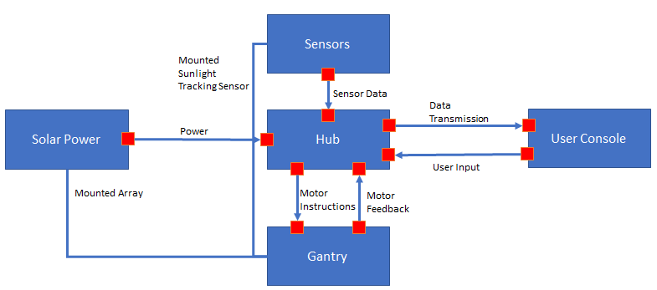

**Figure 1. High Level System** The high level system diagram of the project is shown. The high level system illustrates the overall process flow of how the different project components interact with each other. The solar power system powers the hub; the hub receives data from the sensors and transmits that data to a user console all while providing motor instructions to the motors on the gantry. The solar power system, sensors, user console, and gantry all share a common connection to the system known as “the hub”. The solar power system, sensors, and hub are all physically mounted on the gantry.

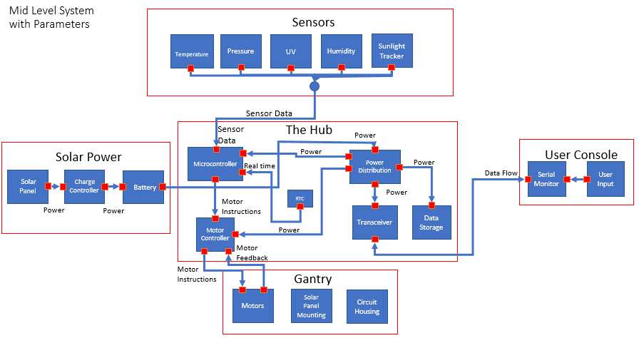

**Figure 2. Mid-Level System.** The mid-level system diagram of the project is shown. The diagram provides a more in depth look at each component of the high level system. The solar panel charges the battery; the battery provides power to the power distribution system of the hub, which then feeds power to the rest of the hub. The various sensors each read data to the hub’s microcontroller. All that real time data flows to both the data storage system and transceiver. The transceiver transmits the data to the user console. The hub’s microcontroller provides instructions to the motor controller; the hub’s motor controller then sends instructions to the motors on the gantry.

# Technical objectives:

1. Design and implement an automated weather station

i. SAWS will use UV light to power hardware

ii. SAWS will track the sun to provide a constant source of energy

iii. SAWS will store power in a battery to provide power during the night cycle.

iv. SAWS will record temperature, humidity, UV light intensity, and barometric pressure.

1. User will be able to access data

i. SAWS will transmit data via Bluetooth to a user console such as a smart phone

ii. SAWS will store sensor data

1. Weather station will have a movable framework

i. SAWS will use motors to move the solar panel

# Acceptance Testing :

# 

# Demonstration Results:

# Lessons Learned:

A number of lessons were learned during the phase of this project. The subject of problems encountered during this project included PCB design, type of materials used, and the mechanical design.

The design and construction of the PCB used for the hub were issues to be considered for future projects. The PCB for the hub was initially being designed through Altium Circuit Maker. The number of sensors, breakouts, motor drivers, and various power components, all required specific pin connections to the microcontroller. Errors were encountered during simulation, and we found difficulty in finding the specific CAD files for the breakouts being using for the hub. With the errors encountered in the PCB simulation, difficulty locating specific CAD files, and the projected cost of having the PCB printed, a final decision was made to construct PCB ourselves. Constructing the PCB proved to have certain benefits. One being that it provided more freedom and flexibility of the placement of all the breakouts, drivers, and other components. It also shed significant cost off the total project cost. However, there was a downside. Building the hub ourselves did shed financial costs, but it did however, cost much time and effort. It cost time to manually test all connections as well as troubleshooting.

Another aspect of the project that ought to be helpful for future projects would be the mechanical design. There are many mechanical engineering design aspects to this weather station. Some include the design of the gears, torque calculations, and weight distribution. The importance of the gear design is crucial to the rotation of the axis. A lesson learned was that a different type of material other than MDF could have been used for the gears. Having accurate gear ratios is also important so that there is no loose spacing between the gear teeth. Another mechanical lesson learned was that accurate torque calculations must be made to choose the correct motors. The motors being used on both the azimuth and elevation must provide enough torque to overcome external forces of friction and gravity. Weight distribution is another lesson to be taken accounted for. The mounted solar panel will be rotating on the elevation axis. If the center of mass does not match up with the horizontal axle, the weight of the panel system will be distributed unevenly and will cause unnecessary stress on the motors.

# Significant Changes:

# Key Personnel:

Matthew Rosales – Project Manager

·         Matthew Rosales is a senior attending California State University, Long Beach. He currently works as an engineering intern at Irvine Ranch Water District. His responsibilities with IRWD include developing AutoCAD designs to help coordinate with engineers and contractors, and assisting engineers with the commissioning/start-up of various facilities. He also reviews construction plans, electrical submittals, and instrumentation submitted by contractors against company specifications.  As project manager, responsibilities included developing project schedules and responsibilities, procuring cost estimates and budget constraints, coordinating team meetings, overseeing the design, construction, and overall progress of the project. Other contributions include assisting with developing power requirements and building power connections.

(Jordan) Chun-Han Hsu - Power/Design Engineer  
 Jordan Hsu is a fourth year Electrical Engineering student at California State University, Long Beach. He will graduate in May 2017. He was the team lead on an autonomous maze solving robot (MicroMouse) during the 2016-2017 academic year, finishing third in the in house competition that year. He is currently serving as the President for the Long Beach State Student Chapter of Eta Kappa Nu (HKN) Epsilon Theta, while serving as the Vice President-Internal the year before. As Power/Design Engineer, his responsibilities to this project included developing power requirements, designing the power distribution system, building power connections, and assisting with the hub construction.

Garrett Bondoc - Software Engineer/Documentation

Garrett Bondoc is a fourth year Electrical Engineering & Biomedical Engineering student at California State University, Long Beach. He has maintained employment at hourly jobs for the past 5 years and has a deep sense of team building and collaboration. To build his expertise in the field of engineering outside of the classroom setting, he involves himself in an array of interests that include repair of electronics like laptops and gaming consoles as well as custom built automotive sound systems and interior LED lighting. As Software Engineer, his responsibilities to this project included programming the solar tracking algorithms, programming functions for the various sensors, integrating the separate program functions into a main program, and assisting with the construction of the hub

James Donahue - Hardware/Design Engineer

James Donahue is a fourth year Electrical Engineering student with a controls emphasis at California State University, Long Beach. He is currently serving as the President for the IEEE CSULB chapter. James started SophEE in Fall 2016; the program is aimed at teaching hands on skills to sophomores as well as recruiting leaders for the IEEE student branch. The grant funded project was developed to teach 13 students how to build line following robots over the course of the school year. James has experience with embedded microprocessors and microprocessor based system design. He has applicable project experience, having developed a microcontroller based  temperature and pressure data logger for use as a parachute release computer in a model rocket.  As Hardware/Design Engineer, his responsibilities to this project included designing the hub, constructing the hub, constructing the gantry, and developing the solar tracking algorithm

Sakib Karim - Systems Engineer

Sakib Karim is a fifth year candidate for B.S. in Electrical Engineering with Power Systems emphasis at California State University, Long Beach. He is a systems intern at LinQuest Corporation which specializes in systems engineering and integration including enterprise. At LinQuest, Sakib worked on system modeling, scripting using JavaScript to manipulate models, and web development in an Agile environment. Sakib is a project lead and team lead for MicroMouse which consists of an autonomous maze solving robot for the year of 2016-2017 and 2017-2018. As Systems Engineer, his responsibilities included developing project requirements, systems design, system testing, acceptance testing, and developing the Bluetooth connection and app design.

# Final Parts List/Cost:

Arduino Mega 2560 Rev3………………………………………………………….  $38.50

[BME280 sensor](https://www.adafruit.com/product/2652) ………………………………………………………………….... $19.95

[UV sensor](https://www.adafruit.com/product/2899) …………………………………………………………………………    $8.10

[Charge Controller](https://www.amazon.com/Battery-Tender-021-1162-Charger-Controller/dp/B004Q820UK/ref=sr_1_4?s=lawn-garden&ie=UTF8&qid=1505322604&sr=1-4&refinements=p_n_feature_keywords_two_browse-bin%3A6907037011%7C6907038011) …………………………………………………………………   $16.95

[Solar panel 10W 12V](https://www.amazon.com/Newpowa-Polycrystalline-Efficiency-Module-Marine/dp/B00W80N8TA/ref=sr_1_11?s=lawn-garden&ie=UTF8&qid=1505322604&sr=1-11&refinements=p_n_feature_keywords_two_browse-bin%3A6907037011%7C6907038011) …………………………………………………………….    $25.99

Real Time Clock…………………………………………………………………..    $9.90

NEMA 17 Stepper Motors………………………………………………………… $39.00

[Bluetooth Transceiver](https://www.amazon.com/Adafruit-PID-1697-Bluefruit-Bluetooth/dp/B01HN72K14/ref=pd_sim_147_24?_encoding=UTF8&pd_rd_i=B01HN72K14&pd_rd_r=HTQPSJ9WFMTD5F994AFD&pd_rd_w=HP01L&pd_rd_wg=pNsoC&psc=1&refRID=HTQPSJ9WFMTD5F994AFD) ……………………………………………………….......    $19.99

16GB SD card…………………………………………………………………….    $7.66

[Photoresistor](https://www.amazon.com/goeasybuy-Sensitive-Resistor-Photoresistor-Optoresistor/dp/B01CGCNO34/ref=sr_1_1?ie=UTF8&qid=1505602666&sr=8-1&keywords=photoresistors) …………………………………………………………………….     $5.99

[Sealed Lead Acid Battery](https://www.amazon.com/gp/product/B01N99YRAD/ref=s9_dcacsd_dcoop_bw_c_x_1_w?th=1)………………………………………………………..    $15.99

[Stepper Driver board](https://www.amazon.com/dp/B014KMHSW6/ref=asc_df_B014KMHSW65172808/?tag=hyprod-20&creative=395033&creativeASIN=B014KMHSW6&linkCode=df0&hvadid=167139094796&hvpos=1o6&hvnetw=g&hvrand=12774596977868057997&hvpone=&hvptwo=&hvqmt=&hvdev=c&hvdvcmdl=&hvlocint=&hvlocphy=9060029&hvtargid=pla-306436938191)…………………………………………………………….     $16.39

MicroSD breakout………………………………………………………………. $8.84

JST Connector – SH 6 PIN………………………………………………………. $1.90

JST Connector – S2B-PH-K-S(LF)(SN)………………………………………….. $1.90

MDF material………………………………………………………………………...$22.92

Hardware & Supplies………………………………………………………………... $14.97

Tb6612 driver…………………………………………………………………………$8.02

Tb6612 driver…………………………………………………………………………$8.40

**Total__________________________________________________________ $291.36**

# References

1. EEEnthusiast. (2016, July 4). Arduino based Solar Tracker - Stepper Motor & Light Resistor Tutorial [Online]. Available: <https://www.youtube.com/watch?v=W3EpomxomR4>
2. Hectorhhg. (2015, January 19). Stepper Motor + Arduino + Solar Tracker (EV) [Online]. Available: <http://www.instructables.com/id/Stepper-Motor-Arduino-Solar-Tracker-EV/>
3. Center for Climate and Energy Solutions. (2012, October). Solar Power [Online]. Available: <https://www.c2es.org/technology/factsheet/solar>
4. Brown Dog Gadgets. (2015, March 4) Dual Axis Solar Tracker - DIY Arduino Powered [Online]. Available <https://www.youtube.com/watch?v=-f6FthqPwog&feature=share>
5. physics.org. (2017, September 17) How do solar cells work? [Online]. Available: http://www.physics.org/article-questions.asp?id=51